JFC is short for Java Foundation Classes, which encompass a group of features for building graphical user interfaces (GUIs) and adding rich graphics functionality and interactivity to Java applications. It is defined as containing the Swing features shown as below.

|  |  |
| --- | --- |
| **Feature** | **Description** |
| Swing GUI Components | Includes everything from buttons to split panes to tables. Many components are capable of sorting, printing, and drag and drop, to name a few of the supported features. |

The goal of this lesson is to introduce the Swing API by designing a simple application. Its GUI will be basic, focusing on only a subset of the available Swing components. We will use the NetBeans IDE GUI builder, which makes user interface creation a simple matter of drag and drop. Its automatic code generation feature simplifies the GUI development process, letting you focus on the application logic instead of the underlying infrastructure.

**AWT to Swing:** earlier, we used AWT to develop GUI, but now we have Swing which is lighter and powerful.

**AWT: Abstract Windowing Toolkit**

import java.awt.*

**Swing: new with Java 2**

import javax.swing.*

Extends AWT

New improved components

Standard dialog boxes, tooltips, …

Look-and-feel, skins

Event listeners

**GUI Component API : Some are listed below and you have many more components…**

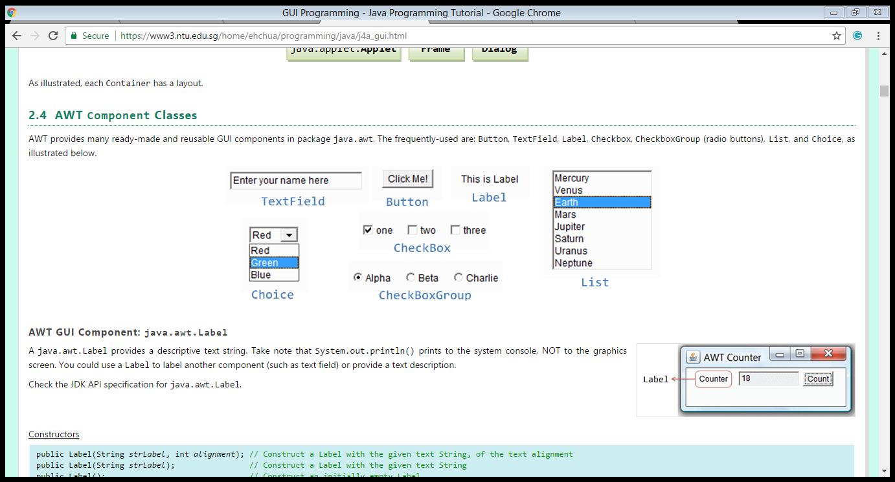

**Using a GUI Component: Step by step proces**

1. **Create it**
   * + Instantiate object: b = new JButton(“press me”);
2. **Configure it**
   * + Properties: b.text = “Click Me”;
     + Methods: b.setText(“press me”);
3. **Add it**
   * + panel.add(b);
4. **Listen to it – when you want to perform an event based on user action we use Listeners.** 
   * + Events: Listeners – are listening to the component and when there’s an action (state change e.g. Button click , mouse over) it will trigger an event.

**Internal structure of a UI:**

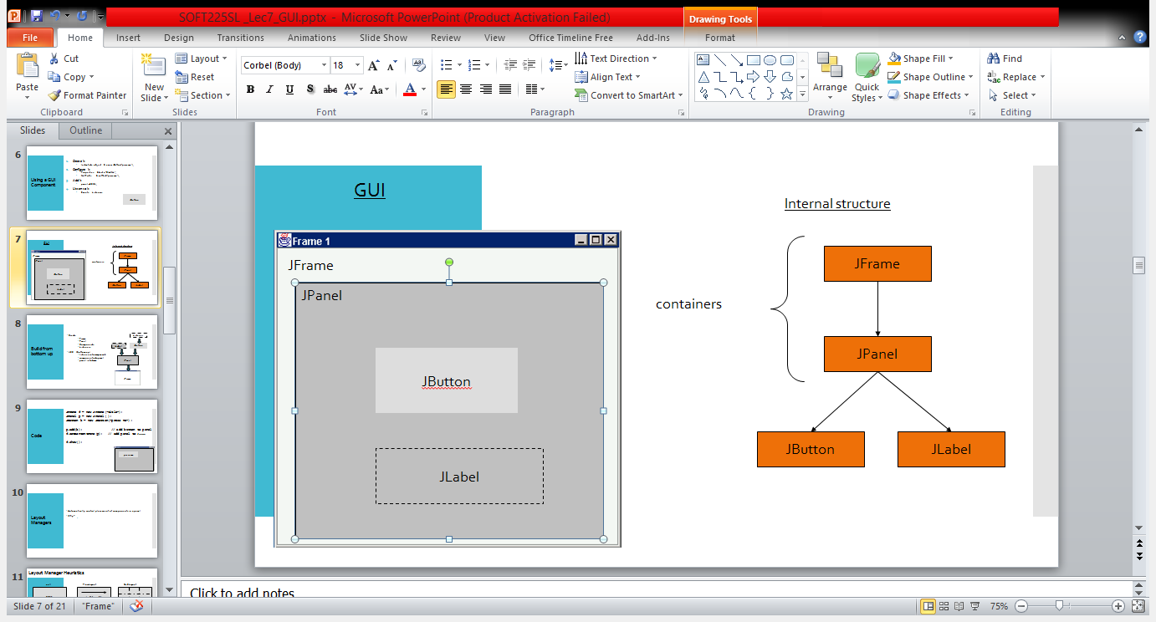

Internal Structure

JFrame

JPanel

JButton

JLabel

containers

**Introduction to GUI Building Using Netbeans:**

Please follow the link below. This gives you a detailed description on how to develop a UI using Netbeans. Complete the steps and build your first UI ☺

<https://netbeans.org/kb/docs/java/gui-functionality.html>

Next, try to develop the following user interfaces.. For last interface, you don’t need to make any actions..

The following UI is used to change the background color of the UI. When user press on the button color will change…

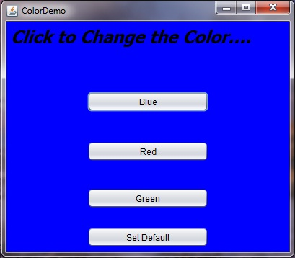

This is a click counter UI. When you press the button it will increment the number of clicks. Start from 0…

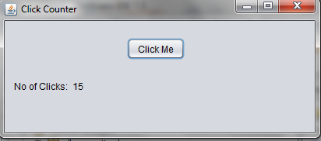

Bit complex UI with different components.

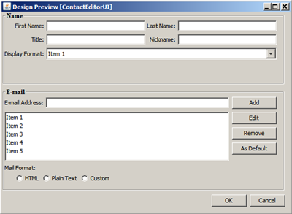

package com.mycompany.gui;

import java.awt.Color;

public class NewJFrame extends javax.swing.JFrame {

public NewJFrame() {

initComponents();

}

@SuppressWarnings("unchecked")

// <editor-fold defaultstate="collapsed" desc="Generated Code">//GEN-BEGIN:initComponents

private void initComponents() {

jPanel1 = new javax.swing.JPanel();

btnblue = new javax.swing.JButton();

btnred = new javax.swing.JButton();

btngreen = new javax.swing.JButton();

btnsetdefault = new javax.swing.JButton();

jLabel1 = new javax.swing.JLabel();

setDefaultCloseOperation(javax.swing.WindowConstants.EXIT_ON_CLOSE);

btnblue.setText("Blue");

btnblue.addActionListener(new java.awt.event.ActionListener() {

public void actionPerformed(java.awt.event.ActionEvent evt) {

btnblueActionPerformed(evt);

}

});

btnred.setText("Red");

btnred.addActionListener(new java.awt.event.ActionListener() {

public void actionPerformed(java.awt.event.ActionEvent evt) {

btnredActionPerformed(evt);

}

});

btngreen.setText("Green");

btngreen.addActionListener(new java.awt.event.ActionListener() {

public void actionPerformed(java.awt.event.ActionEvent evt) {

btngreenActionPerformed(evt);

}

});

btnsetdefault.setText("Set Default");

btnsetdefault.addActionListener(new java.awt.event.ActionListener() {

public void actionPerformed(java.awt.event.ActionEvent evt) {

btnsetdefaultActionPerformed(evt);

}

});

jLabel1.setFont(new java.awt.Font("Monotype Corsiva", 0, 36)); // NOI18N

jLabel1.setText("Click to Change the Color");

javax.swing.GroupLayout jPanel1Layout = new javax.swing.GroupLayout(jPanel1);

jPanel1.setLayout(jPanel1Layout);

jPanel1Layout.setHorizontalGroup(

jPanel1Layout.createParallelGroup(javax.swing.GroupLayout.Alignment.LEADING)

.addGroup(jPanel1Layout.createSequentialGroup()

.addGroup(jPanel1Layout.createParallelGroup(javax.swing.GroupLayout.Alignment.LEADING)

.addGroup(jPanel1Layout.createSequentialGroup()

.addGap(181, 181, 181)

.addGroup(jPanel1Layout.createParallelGroup(javax.swing.GroupLayout.Alignment.LEADING)

.addComponent(btnred)

.addComponent(btnblue)

.addComponent(btngreen)))

.addGroup(jPanel1Layout.createSequentialGroup()

.addGap(173, 173, 173)

.addComponent(btnsetdefault))

.addGroup(jPanel1Layout.createSequentialGroup()

.addGap(28, 28, 28)

.addComponent(jLabel1, javax.swing.GroupLayout.PREFERRED_SIZE, 410, javax.swing.GroupLayout.PREFERRED_SIZE)))

.addContainerGap(47, Short.MAX_VALUE))

);

jPanel1Layout.setVerticalGroup(

jPanel1Layout.createParallelGroup(javax.swing.GroupLayout.Alignment.LEADING)

.addGroup(jPanel1Layout.createSequentialGroup()

.addGap(16, 16, 16)

.addComponent(jLabel1, javax.swing.GroupLayout.PREFERRED_SIZE, 56, javax.swing.GroupLayout.PREFERRED_SIZE)

.addGap(29, 29, 29)

.addComponent(btnblue)

.addGap(36, 36, 36)

.addComponent(btnred)

.addGap(36, 36, 36)

.addComponent(btngreen)

.addGap(30, 30, 30)

.addComponent(btnsetdefault)

.addContainerGap(37, Short.MAX_VALUE))

);

javax.swing.GroupLayout layout = new javax.swing.GroupLayout(getContentPane());

getContentPane().setLayout(layout);

layout.setHorizontalGroup(

layout.createParallelGroup(javax.swing.GroupLayout.Alignment.LEADING)

.addComponent(jPanel1, javax.swing.GroupLayout.Alignment.TRAILING, javax.swing.GroupLayout.DEFAULT_SIZE, javax.swing.GroupLayout.DEFAULT_SIZE, Short.MAX_VALUE)

);

layout.setVerticalGroup(

layout.createParallelGroup(javax.swing.GroupLayout.Alignment.LEADING)

.addGroup(javax.swing.GroupLayout.Alignment.TRAILING, layout.createSequentialGroup()

.addComponent(jPanel1, javax.swing.GroupLayout.DEFAULT_SIZE, javax.swing.GroupLayout.DEFAULT_SIZE, Short.MAX_VALUE)

.addContainerGap())

);

pack();

setLocationRelativeTo(null);

}// </editor-fold>

private void btnblueActionPerformed(java.awt.event.ActionEvent evt)

{

jPanel1.setBackground(Color.BLUE);

}

private void btnredActionPerformed(java.awt.event.ActionEvent evt)

{

jPanel1.setBackground(Color.RED);

}

private void btngreenActionPerformed(java.awt.event.ActionEvent evt)

{

jPanel1.setBackground(Color.GREEN);

}

private void btnsetdefaultActionPerformed(java.awt.event.ActionEvent evt)

{

jPanel1.setBackground(Color.LIGHT_GRAY);

}

public static void main(String args[]) {

java.awt.EventQueue.invokeLater(new Runnable() {

public void run() {

new NewJFrame().setVisible(true);

}

});

}

private javax.swing.JButton btnblue;

private javax.swing.JButton btngreen;

private javax.swing.JButton btnred;

private javax.swing.JButton btnsetdefault;

private javax.swing.JLabel jLabel1;

private javax.swing.JPanel jPanel1;

}

package com.mycompany.gui;

public class Gui {

public static void main(String[] args) {

NewJFrame c=new NewJFrame();

c.show();

}

}